DWH ASSIGNMENT 1 – SWIGGY

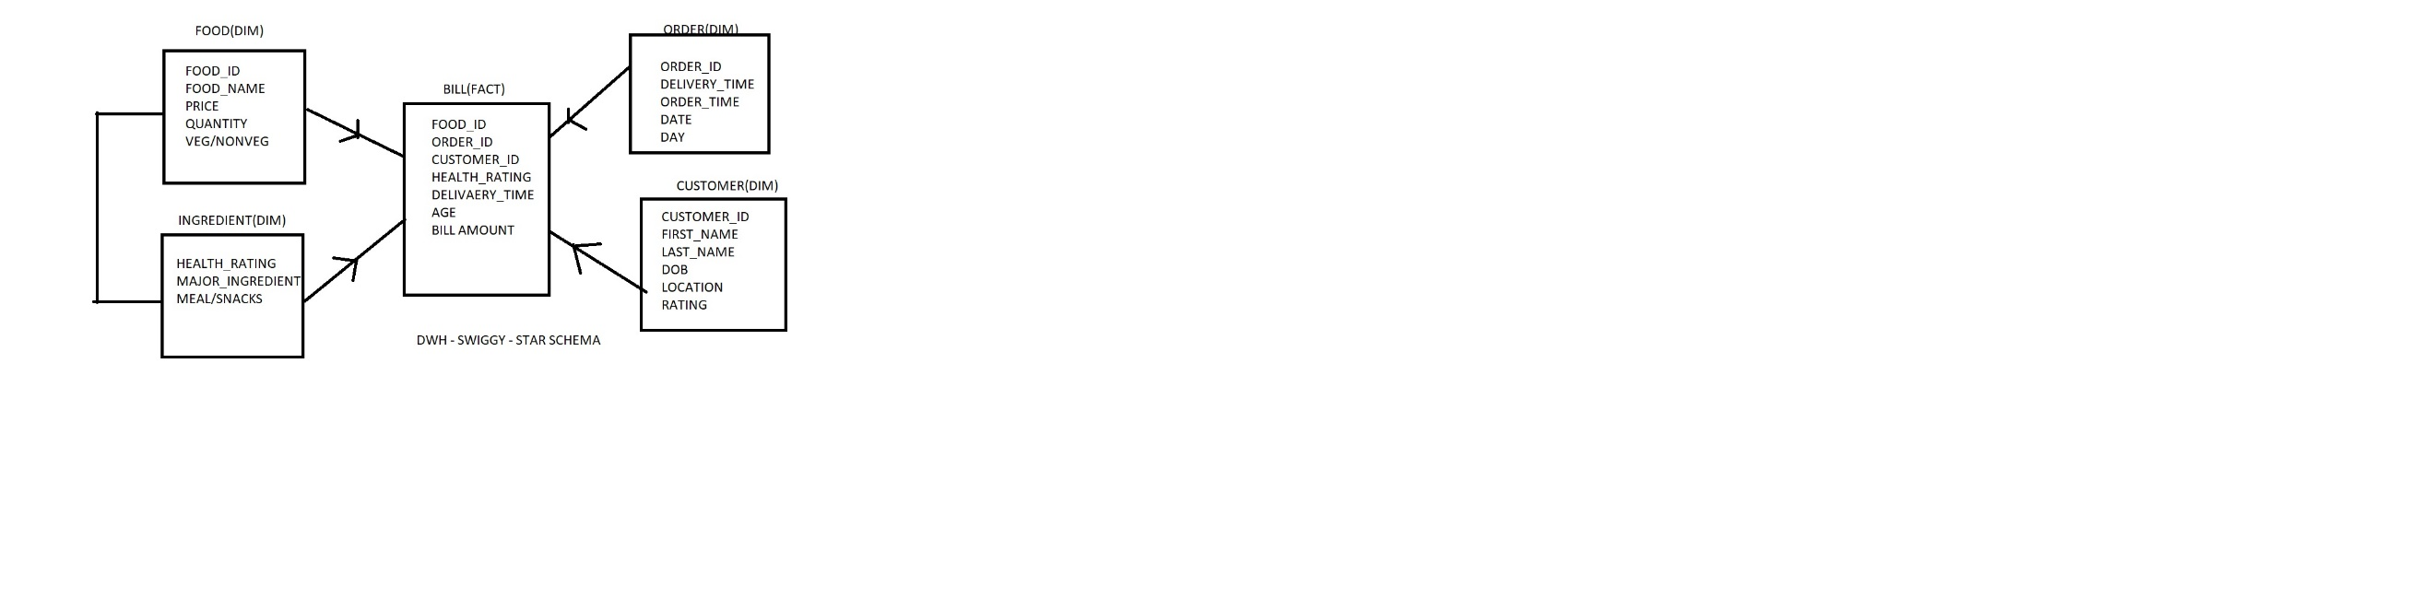

BUSSINESS PROCESS:

1. FROM WHICH LOCATION/CITY DO WE GET MAX/MIN ORDERS?
2. ON WHICH DATES/DAYS DO WE GET MAX/MIN ORDERS
3. DO CUSTOMERS MAJORLY PREFER TO ORDER SNACKS/MEAL?
4. WHICH AGE GROUP OF CUSTOMERS FOCUS ON HEALTHY DIET?
5. WHICH AGE GROUP OF CUSTOMERS ORDER MORE?
6. WHICH IS THE MOST FREQUENTLY ORDERED FOOD?
7. IS VEG FOOD ORDERED MORE OR NON VEG?
8. IN WHICH LOCATIONS IS DELIVERY FASTER?

DWH ASSIGNMENT 2 - DWH FOR CAR RIDE APP

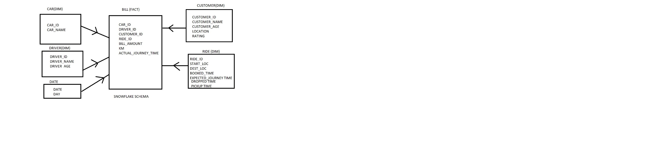

DWH ASSIGNMENT 3 – DWH FOR RESTAURANT APP

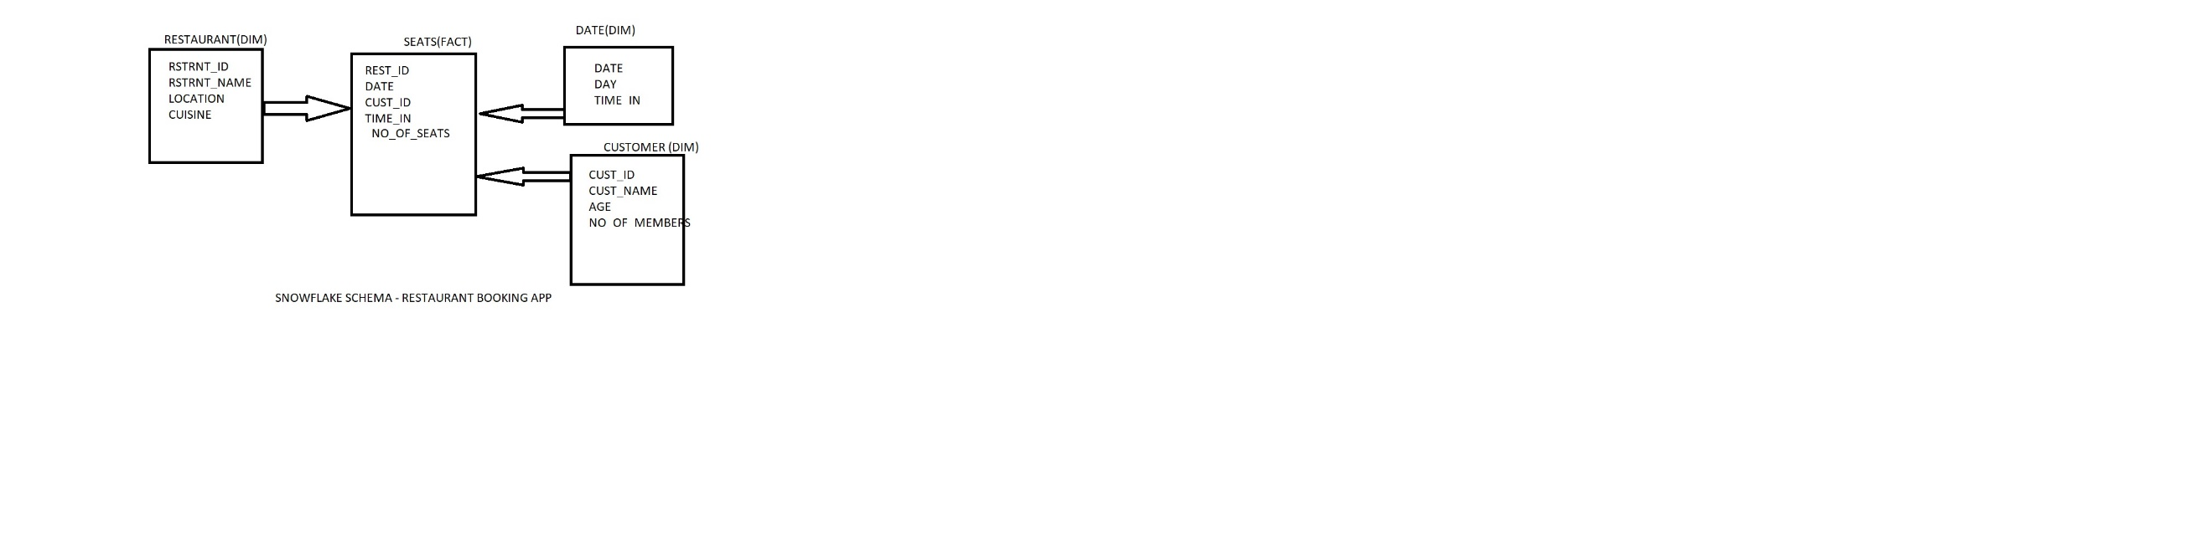

ASSIGNMENT 4 – DWH FOR COVID VACCINATION APP

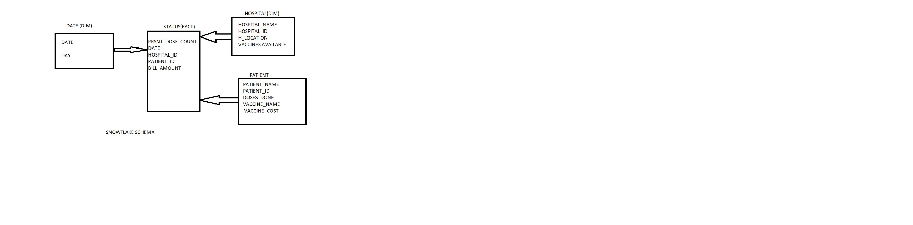

ASSIGNMENT 5 -

